PCPS COLLEGE
Department of Information Technology
Week 2 Practical – HTML Fundamentals

Name: Bibash Kumal
Subject: CIS092-1 Fundamental of Software Engineer
Section: C
Date: 23 Sept., 2026

TASK-1 BASIC HTML STRUCTURE:
Programming code:
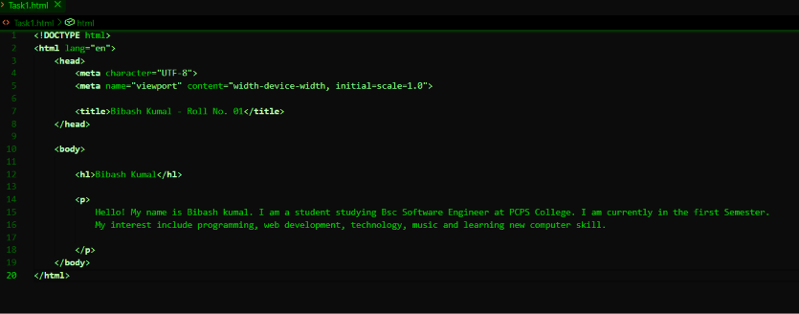
OUTPUT:
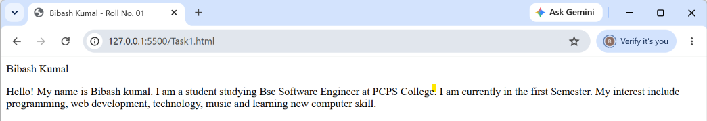

TASK-2 TEXT FORMATTING:
Programming code:
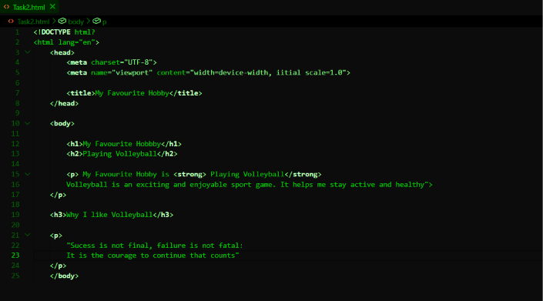

OUTPUT:
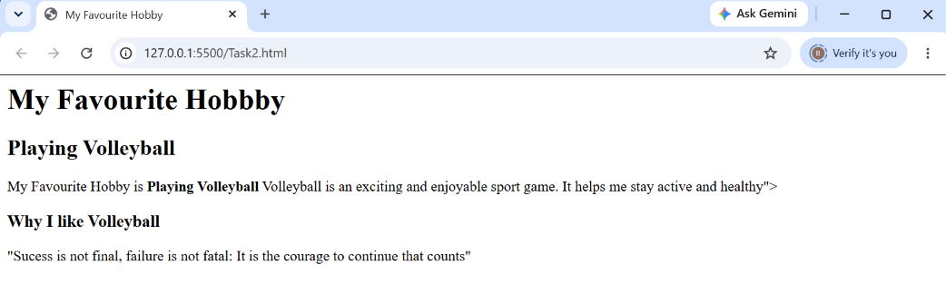

TASK-3 LISTS:
Programming code:
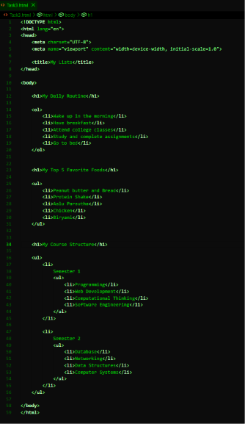
OUTPUT:
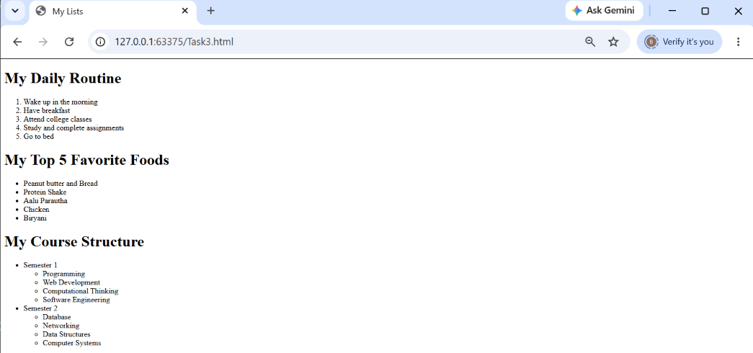

TASK-4: Links and Images.
Programming code:
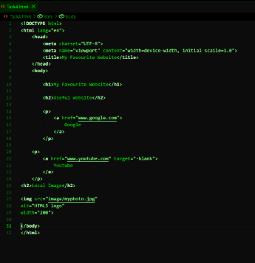

OUTPUT:
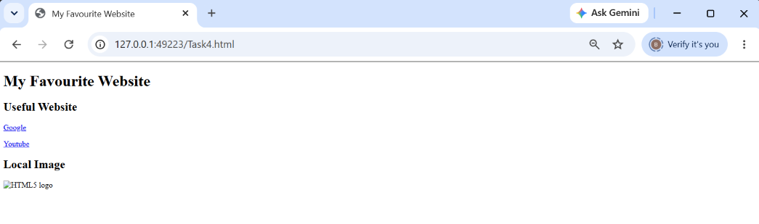

TASK-5: TABLES.
Programming code:
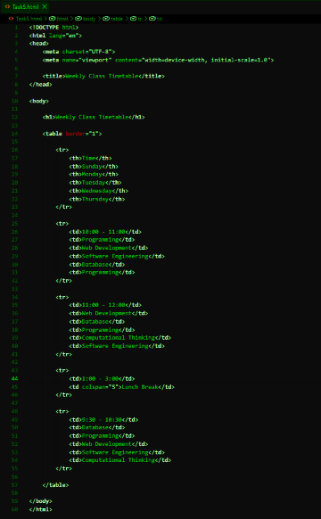
OUTPUT:
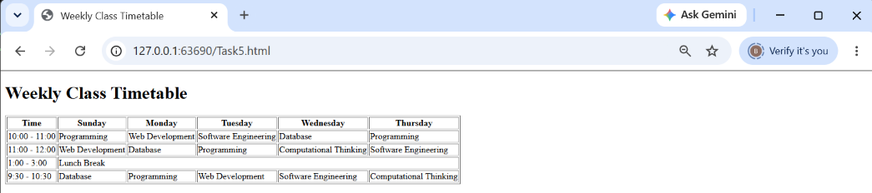
Task-6: Student Registration Form.
Programming code:
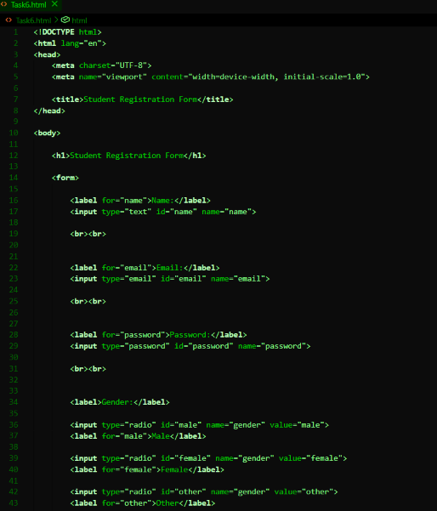
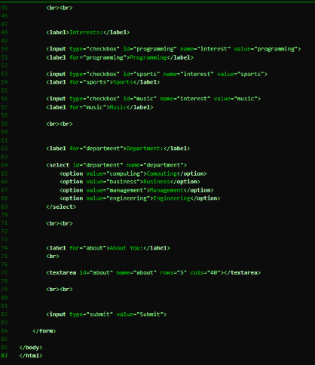

OUTPUT:
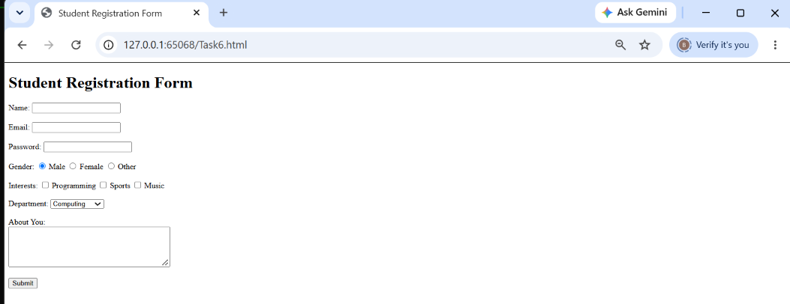

Task-7: Semantic HTML
Programming code:
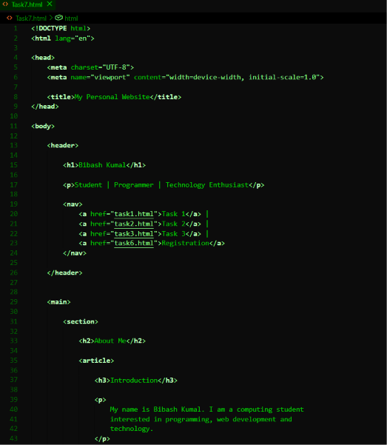
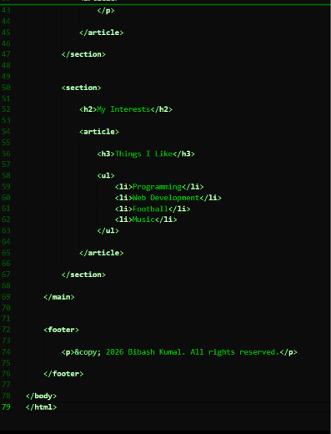
OUTPUT:
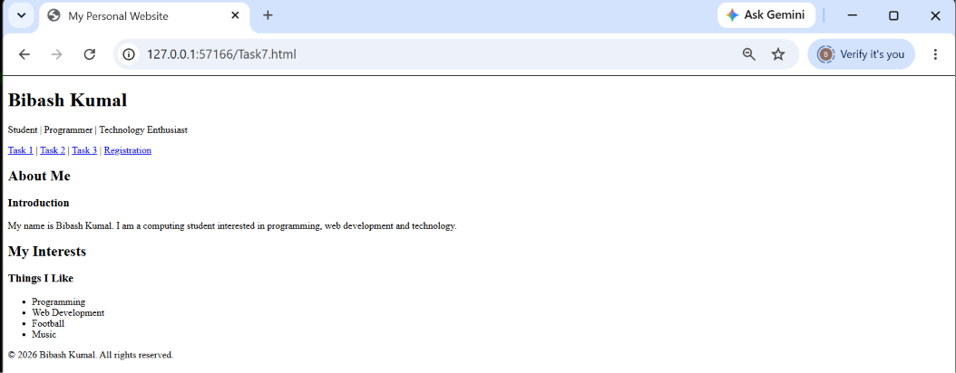

TASK-8: Embedding Content
Programming Code:
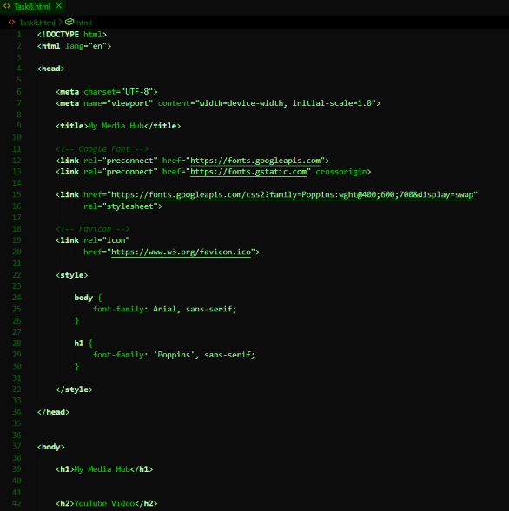
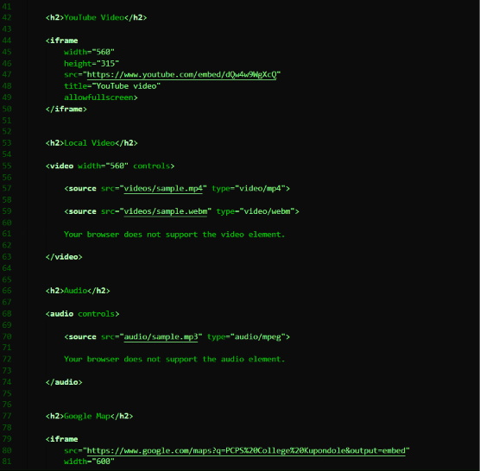
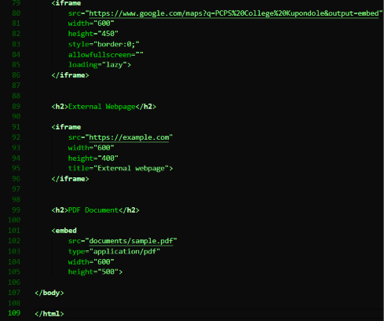
OUTPUT:
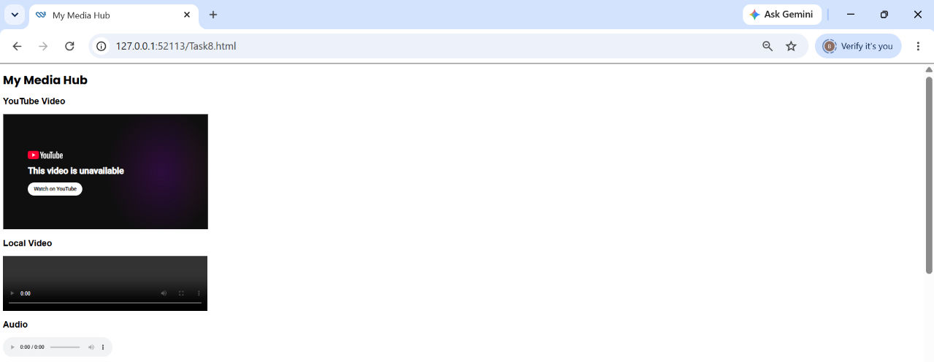
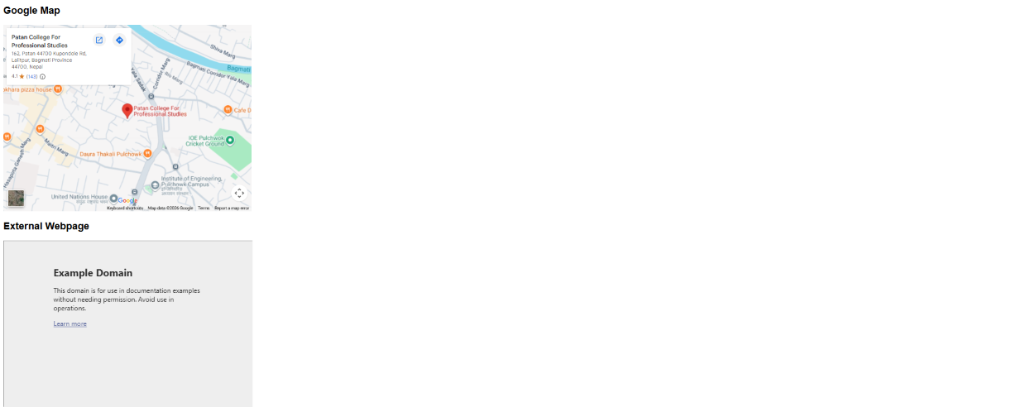
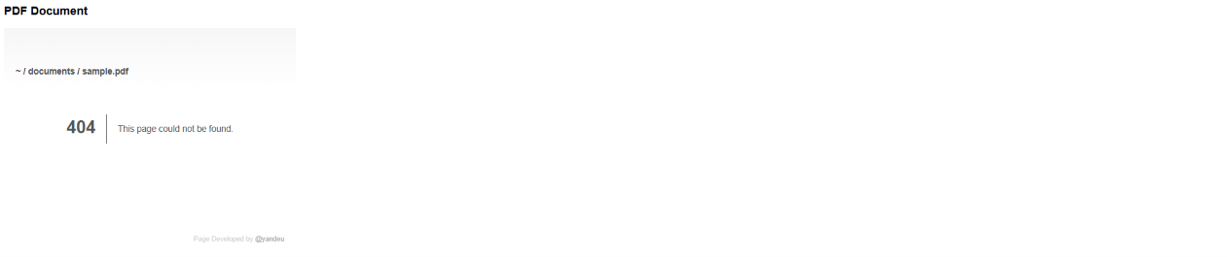
TASK-9: Mini Project: Personal Portfolio
9.1 index.html
Programming code:
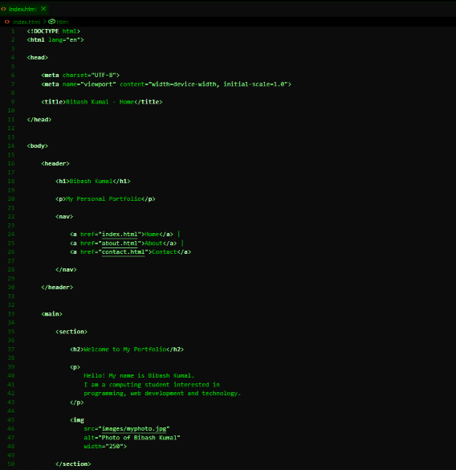
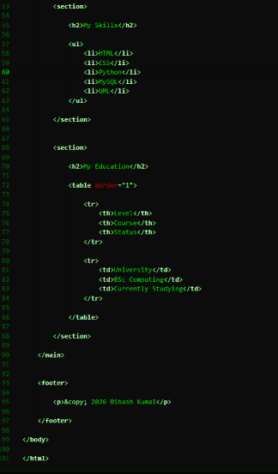

OUTPUT:
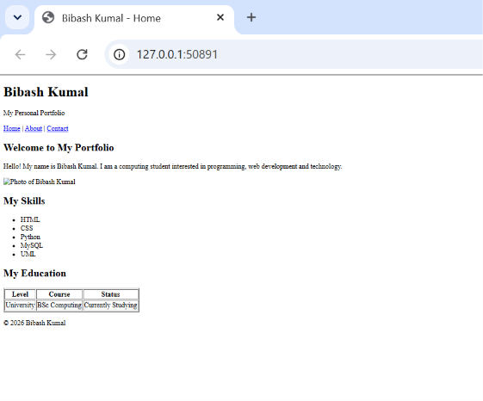

9.2 about.html
Programming code:
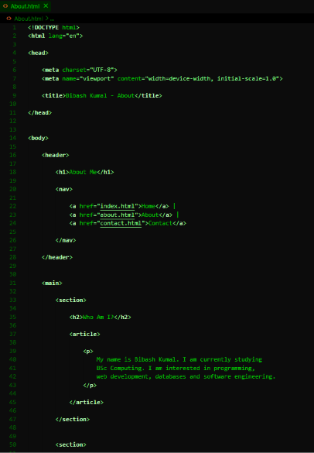
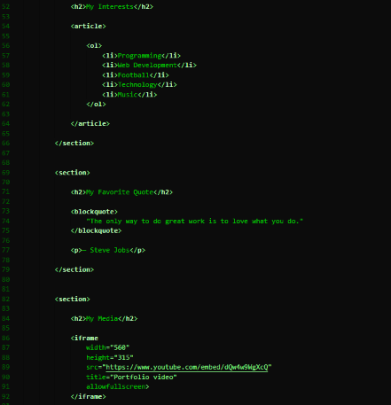
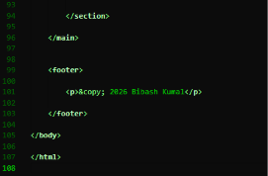
OUTPUT:
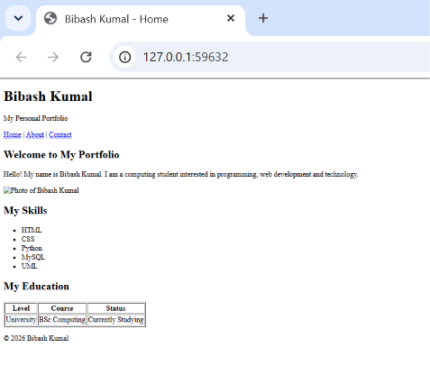

9.3 Contact.HTML:
Programming code:
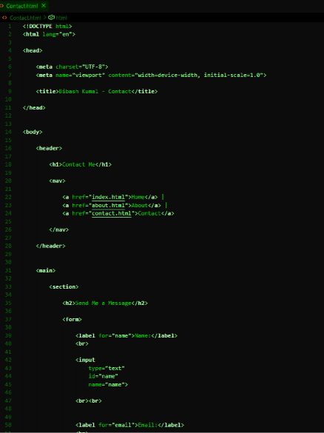
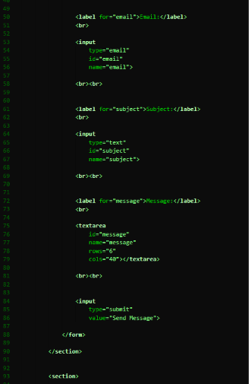
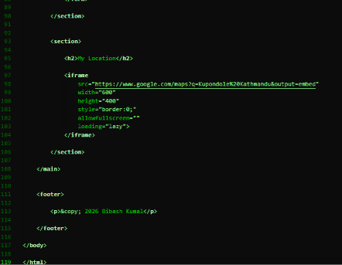
OUTPUT:
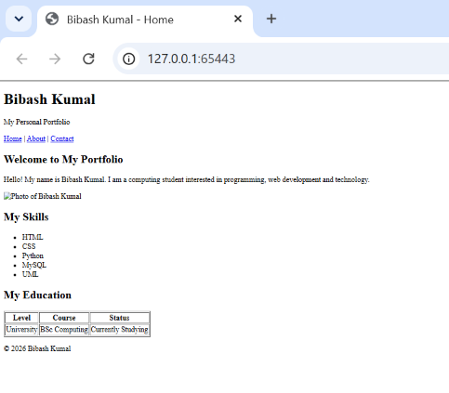

Github link: https://github.com/bibashkumal-dev/HTML_PRACTICE-_WEE-2_-BIBASH_KUMAL-.git

